You work for XYZ Corporation. Their application requires a storage service that

can store files and publicly share them if required. Implement S3 for the same.

**Tasks To Be Performed:**

1. Create an S3 Bucket for file storage.

2. Upload 5 objects with different file extensions.

Soln🡪

Go to s3 dashboard and click on create s3 bucket.

Fill the details

Click on create bucket.

Now open your bucket and upload the 5 objects with different extensions.

Click on add files.

Here we can see we have uploaded files with different different extensions.

**Tasks To Be Performed:**

1. Enable versioning for the bucket created in task 1.

2. Re-upload any 2 files already uploaded to verify if versioning works.

Now to enable versioning for our bucket.

Go to properties and edit the bucket versioning.

Enable it and save changes.

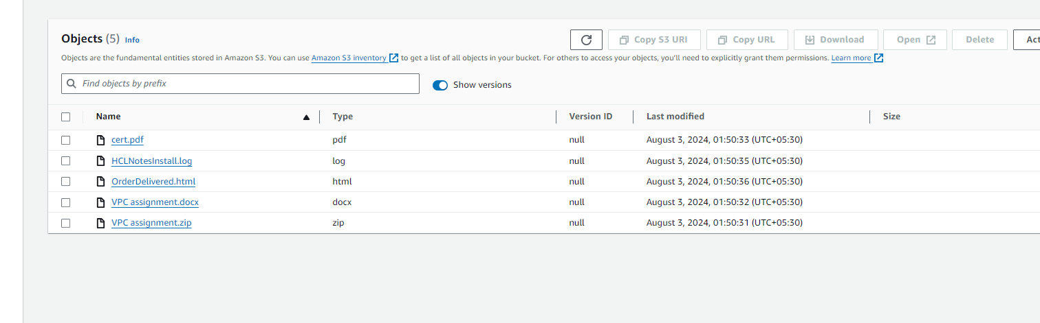

Now let’s upload two same files to verify.

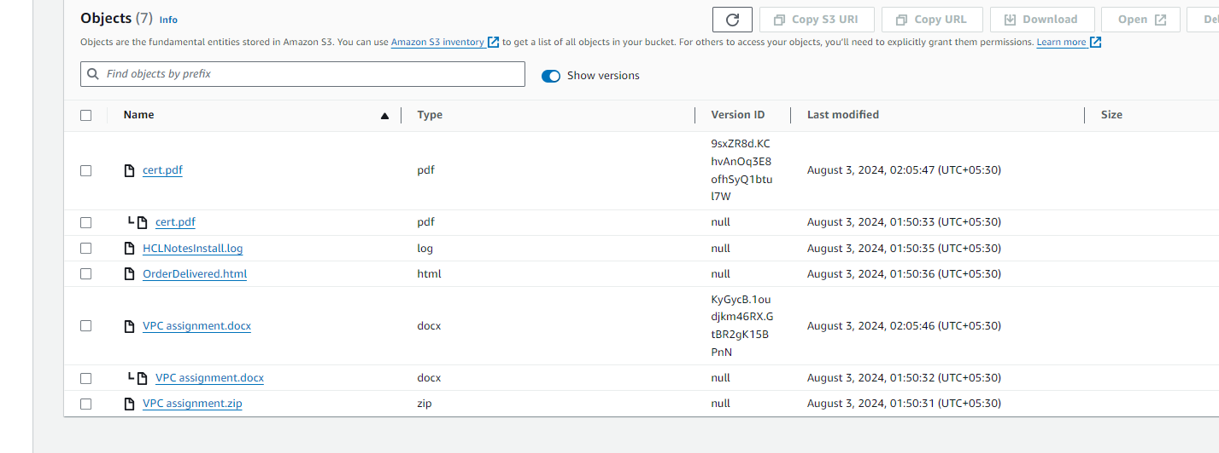

We can see old and new versions.

1. Use the created bucket in the previous task to host static websites, upload

an index.html file and error.html page.

2. Add a lifecycle rule for the bucket:

a. Transition from Standard to Standard-IA in 60 days

b. Expiration in 200 days

Lets host a specific site on our bucket.

First enable allow public access on our bucket so we can verify it.

And also allow user to access it on internet.

Now go in properties and go down u can see host static website setting.

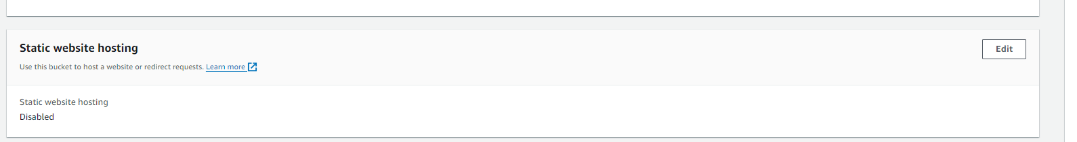

But before this just upload the html files which we are needing.

Fill the details and save it . u will get the url when u save it.

Access the page using this url.

2. Add a lifecycle rule for the bucket:

a. Transition from Standard to Standard-IA in 60 days

b. Expiration in 200 days

Now lets add lifecycle rules.-->

Go in management and create lifecycle rule🡪

Create the rule.